A REASON TO HOPE | 1 PETER 1:6-12
WAVE CHURCH SD | MAY 31, 2020

REJOICING = PRAISING GOD

A MARK OF AN AUTHENTIC CHRISTIAN IS REJOICING
IN THE MIDST OF DIFFICULTIES

1 Peter 1:3-6 (ESV)
³ Blessed be the God and Father of our Lord Jesus Christ! According to his
great mercy, he has caused us to be born again to a living hope through
the resurrection of Jesus Christ from the dead, ⁴ to an inheritance that is imperishable, undefiled, and unfading, kept in heaven for you, ⁵ who by God’s power are being guarded through faith for a salvation ready to be revealed in
the last time. ⁶ In this you rejoice, though now for a little while, if necessary, you have been grieved by various trials…

TWO REASONS A CHRISTIAN CAN REJOICE IN TRIALS

- THE PROMISE OF A GREAT FUTURE

- GOD HAS A DESIGN FOR MY DISTRESS

- YOUR LEVEL OF DISAPPOINTMENT IS DIRECTLY RELATED TO WHERE YOU PLACE YOUR HOPE.

GOD NEVER WASTES OUR PAIN; HE REPURPOSES IT!

Romans 8:28 (ESV)
And we know that for those who love God all things work together for good, for those who are called according to his purpose.

James 1:2-4 (ESV)
² Count it all joy, my brothers, when you meet trials of various kinds, ³ for you know that the testing of your faith produces steadfastness. ⁴ And let steadfastness have its full effect, that you may be perfect and complete, lacking in nothing.
GROWTH = CHANGE | CHANGE = LOSS | LOSS = PAIN

GROWTH = PAIN

“The difference between where I am and where God wants me to be
is the pain I’m willing to endure.” – Samuel Chand

1 Peter 1:7 (ESV) so that the tested genuineness of your faith—more precious than gold that perishes though it is tested by fire—may be found to result in praise and glory and honor at the revelation of Jesus Christ.

TRIALS TEACH US HOW TO USE OUR FAITH

FAITH IS NOT A SINGLE ACT

FAITH IS A REPETITIVE CHOICE THAT
CAUSES ME TO ACT IN FAITH

1 Peter 1:8-9 (ESV) ⁸ Though you have not seen him, you love him. Though you do not now see him, you believe in him and rejoice with joy that is inexpressible and filled with glory, ⁹ obtaining the outcome of your faith, the salvation of your souls.

HOPE RIGHTLY PLACED NEVER DISAPPOINTS

1 Peter 1:10-12 (ESV) ¹⁰ Concerning this salvation, the prophets who prophesied about the grace that was to be yours searched and inquired carefully, ¹¹ inquiring what person or time the Spirit of Christ in them was indicating when he predicted the sufferings of Christ and the subsequent glories. ¹² It was revealed to them that they were serving not themselves but you, in the things that have now been announced to you through those who preached the good news to you by the Holy Spirit sent from heaven, things into which angels long to look.

Matthew 16:13-18 (ESV) ¹³ Now when Jesus came into the district of Caesarea Philippi, he asked his disciples, “Who do people say that the Son of Man is?” ¹⁴ And they said, “Some say John the Baptist, others say Elijah, and others Jeremiah or one of the prophets.” ¹⁵ He said to them, “But who do you say that I am?” ¹⁶ Simon Peter replied, “You are the Christ, the Son of the living God.” ¹⁷ And Jesus answered him, “Blessed are you, Simon Bar-Jonah! For flesh and blood has not revealed this to you, but my Father who is in heaven. ¹⁸ And I tell you, you are Peter, and on this rock I will build my church, and the gates of hell shall not prevail against it.
CONNECT.
.
WAVE CHURCH ONLINE | Sundays
During this unprecedented time, it is more important than ever that we remain connected even when we are separated. Join us for Wave Church SD ONLINE anytime on Sunday, or during the week. Visit our Website to access the video link, worship videos from members of our worship team, and links to Wave Kids ministry resources.
wavechurchsd.com/church-online
WAVE WEEKLY NEWSLETTER
Want to keep up with all that is going on at Wave? Simply fill out your communication card and write ‘Newsletter’ to get a weekly email update
from Wave!
GROW.
.
SERMON PODCASTS | wavechurchsd.com/sermons/
Want to hear a sermon again, or share it with a friend or family member? Download our sermon podcasts at wavechurchsd.com/sermons/. Access it
on our Website or on the Wave Church SD YouTube channel.
SERVE.
.
HOW CAN YOU HELP YOU? | (858) 465-4144
Wave has developed a texting app for you to text us your prayer requests and physical needs over the coming weeks. With many people self-quarantining, there will certainly be needs and shortages of supplies. This is an opportunity to BE THE CHURCH. Please text your need to (858) 465-4144 and we will seek to share our resources with one another and our neighbors.

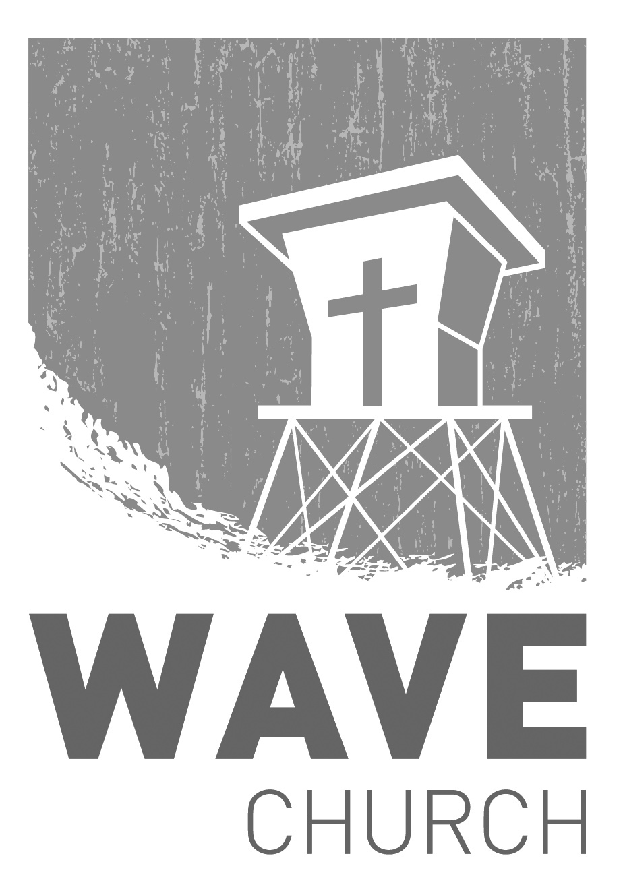
Wave Church

Welcome to

Connect | Grow | Serve

Sundays at 10 a.m.
Willow Grove Elementary
14727 Via Azul
San Diego, CA | 92127
858-859-2831
Wavechurchsd.com

